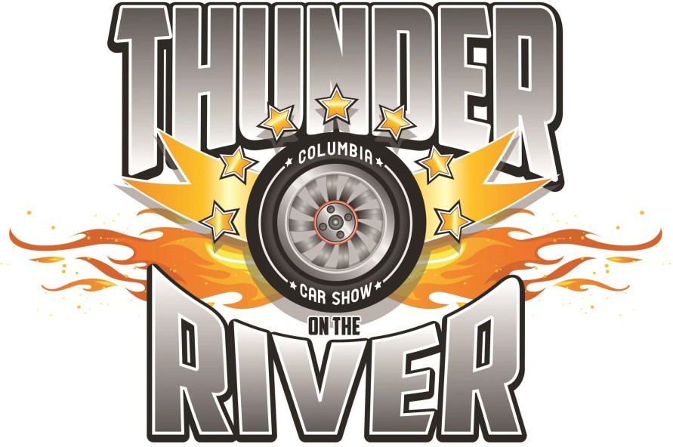
June 18, 2022
Historic Downtown Columbia, PA
Hosted by the Columbia Lions Club
Antique cars—classic cars
custom cars—Muscle Cars—Corvettes Street rods—lead sleds—motorcycles
Like us on Facebook at Thunder on the River
WHERE: Locust Street between Front Street (PA 441) and 6th Street. Enter the show via North 2nd Street. Use Google Maps or Waze address: 21 N. 2nd St., Columbia, PA, 17512.
WHEN: Arrive between 7:00 A.M. and 9:45 AM. The show runs from 10:00 AM to 2:00 PM. NO CARS WILL BE PERMITTED TO ENTER THE SHOW BEFORE 7:00 AM. NO CARS MAY LEAVE BEFORE 2:00 PM. YOUR SHOW PLACEMENT IS BASED ON YOUR TIME OF ARRIVAL. **NO SPECIAL PLACEMENT REQUESTS**
Please bring two non-perishable food items or a donation for the Columbia Food Bank
REGISTRATION: $12 registration through June 11. No registrations will be accepted June 12-17. Same-day registration is $20 on a first-come, first-served basis. 450 vehicles max. You will receive an e-mail confirmation after your registration has been received. Postcards will be mailed when an email address is not available. The first 200 registrants receive a dash plaque. The show is held rain or shine.
PACKET PICKUP: Pick up your show entrance packet at Mountz & Kreiser Law Firm, 553 Locust St., Columbia on the following dates: June 6-9 and June 14-15 from 9:00 AM to 5:00 PM. Early packet pickup is encouraged. Same day packet pickup will also be available as you enter the show.
INFO: Best of Show award, Barry Doutrich Memorial award, trophies and door prizes will be awarded. The festive atmosphere will include a band, food stands and revving of engines at 12:00 noon to simulate Thunder on the River.

50+ TROPHIES each with a $10 gift card
Proceeds benefit CBAA youth sports, Glatfelter Memorial Field, Zion Hill Cemetery and Lions vision/eyeglasses project
For more information, email carshow@columbialions.org
Call (717) 715-3592 or message us on Facebook.

2022 Registration Form
Mail this form with a $12 entry fee to Columbia Lions Club, P.O Box 569, Columbia, PA 17512
Make checks payable to Columbia Lions Club
NAME PHONE

ADDRESS CITY STATE ZIP VEHICLE YEAR MAKE MODEL EMAIL ADDRESS
Liability: In consideration of the right to participate, entrants, participants, and spectators by execution of this entry form release and discharge the sponsoring organization or anyone connected with the presentation of the car show of any and all known and unknown damages, injuries, losses and/or claims from cause whatsoever that may be suffered by any entrant to his/her person or property.

